Statefile

A Terraform state file is a crucial component of Terraform, a popular Infrastructure as Code (IaC) tool used to provision and manage cloud infrastructure. Here’s a detailed overview:

### What is a Terraform State File?

The Terraform state file (often named `terraform.tfstate`) is a JSON file that stores information about the infrastructure managed by Terraform. It tracks the current state of the deployed resources so that terraform knows what exists in the real world and can manage updates and deletions accordingly.

### Key Aspects of the Terraform State File:

1. **Resource Tracking**: The state file keeps track of all resources created by Terraform, including their current state, IDs, and attributes. This allows Terraform to compare the desired state (defined in your configuration files) with the actual state (stored in the state file).

2. **Dependency Management**: It maintains the dependencies between resources. For instance, if a resource A depends on resource B, this relationship is stored in the state file.

3. **Performance**: By caching the state of the infrastructure, Terraform can quickly determine the changes required to achieve the desired state without querying the cloud provider's API repeatedly.

4. **Collaboration**: When used in a team environment, the state file must be shared among team members to ensure consistency. Remote backends (such as Amazon S3, Google Cloud Storage, or Terraform Cloud) are often used to store the state file securely and enable collaboration.

### Managing Terraform State:

- **Remote State Storage**: Storing the state file remotely is a best practice for teams. It ensures that everyone is using the latest state and helps prevent conflicts. Popular remote state backends include AWS S3, GCP Cloud Storage, Azure Blob Storage, and Terraform Cloud.

- **State Locking**: When using remote state storage, state locking can prevent concurrent operations that could corrupt the state file. For example, using DynamoDB for state locking with an S3 backend.

- **State Commands**:

  - `terraform state list`: Lists resources in the state.

  - `terraform state show`: Shows detailed information about a single resource.

  - `terraform state mv`: Moves items within the state.

  - `terraform state rm`: Removes items from the state.

  - `terraform state pull`: Manually downloads the state from the remote backend.

  - `terraform state push`: Manually uploads a local state file to the remote backend.

### Best Practices:

1. **Secure Storage**: Ensure the state file is stored securely, especially if it contains sensitive information.

2. **Backups**: Regularly back up the state file to avoid data loss.

3. **Version Control**: Avoid committing the state file to version control systems like Git. Instead, use remote backends.

4. **State Management**: Regularly run `terraform plan` to detect unintended changes and ensure your state file is in sync with the real infrastructure.

5. **Modules and State Files**: Use separate state files for different environments (e.g., development, staging, production) or for different parts of your infrastructure to reduce complexity and potential conflicts.

Understanding and properly managing the Terraform state file is essential for successful and efficient infrastructure management using Terraform.

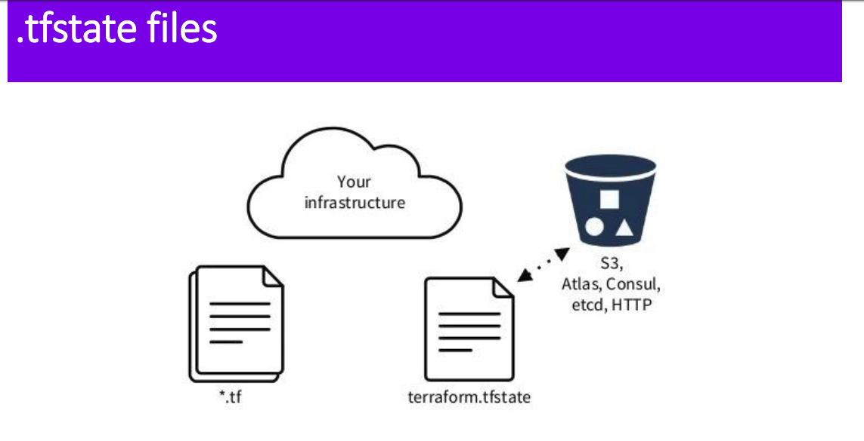

Remote backend

In Terraform, a **remote backend** is a way to store the Terraform state file remotely, allowing multiple users to collaborate on the same Terraform configuration. Using a remote backend ensures that the state file is not stored locally, which helps avoid conflicts and ensures that everyone is working with the most up-to-date state.

Here’s a general overview of how to configure a remote backend in Terraform:

**Steps to Configure a Remote Backend**

1. **Choose a Backend Type**: Terraform supports multiple remote backend types such as S3, Azure Storage, Google Cloud Storage, Consul, etc.
2. **Configure the Backend in the Terraform Configuration**: Add the backend configuration block to your Terraform configuration file (main.tf or a separate file like backend.tf).
3. **Initialize the Backend**: Run terraform init to initialize the backend.

**Example: Configuring an S3 Backend**

Here's an example of how to configure an S3 backend in Terraform:

1. **Create an S3 Bucket**: Ensure you have an S3 bucket created in AWS. You can also set up DynamoDB for state locking and consistency checking.
2. **Update Your Terraform Configuration**:

terraform {

backend "s3" {

bucket = "my-terraform-state-bucket"

key = "path/to/my/terraform.tfstate"

region = "us-west-2"

dynamodb_table = "my-lock-table" # Optional, for state locking

encrypt = true

}

}

1. **Initialize the Configuration**: Run the following command in your terminal:

Sh terraform init

**Other Remote Backend Examples Azure Blob Storage**

terraform {

backend "azurerm" {

storage_account_name = "mystorageaccount"

container_name = "tfstate"

key = "path/to/my/terraform.tfstate"

}

}

**Google Cloud Storage**

terraform {

backend "gcs" {

bucket = "my-terraform-state-bucket"

prefix = "terraform/state"

}

}

**HashiCorp Consul**

terraform {

backend "consul" {

address = "demo.consul.io"

path = "terraform/state"

}

}

**Notes**

* **State Locking**: Some backends support state locking, which helps prevent concurrent operations that could lead to conflicts. For example, AWS S3 can use DynamoDB for state locking.
* **Credentials**: Ensure your environment is configured with the necessary credentials to access the remote backend (e.g., AWS CLI configured with access keys, Azure CLI logged in, Google Cloud SDK authenticated, etc.).
* **Workspace Support**: Remote backends support Terraform workspaces, allowing you to manage different environments (e.g., dev, staging, production) easily.

**Best Practices**

* **Secure Your State**: Ensure that the state file stored in the remote backend is secure. Use encryption and proper access controls to prevent unauthorized access.
* **Version Control**: Keep your backend configuration in version control, but do not include sensitive information such as access keys.
* **State Management**: Regularly back up your state file and be aware of the state management commands (terraform state commands) to manipulate state when necessary.

Using a remote backend in Terraform enhances collaboration and ensures better state management for your infrastructure as code (IaC) deployments.